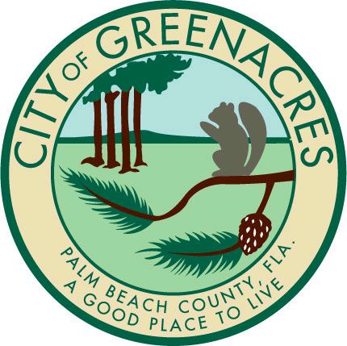

City of Greenacres

Development and Neighborhood Services

Engineering Permit Review Fee Worksheet
Date:
Project :___________________ Permit Number _______________
City Administrative Review Fee: $ 75.00

City Engineering Review Fee:
Total Plat Acreage Fee for Review $
PLAT TOTAL ACREAGE | Fee for Review
0.01‐1.00 | $1,520.00
1.01‐3.00 | $1,900.00
3.01‐5.00 | $2,280.00
5.01‐7.00 | $2,660.00
7.01‐10.00 | $3,040.00
10.01‐15.00 | $3,420.00
15.01 ‐20.00 | $4,560.00
Projects Greater than 20 acres shall be calculated by City Consultant and reviewed and agreed upon by City prior to review.

City Engineering Inspection Fee:
Drainage, Grading, Paving, Marking,
And Signage. $
Please attach contract Cost Estimate

3% of cost estimate $
Cost Estimate
Cost Estimate
Total Amount: $

